Matter Center for Office 365

Build and deployment guide

Table of contents

Matter Center deployment 4

Pre-requisites 4

Deployment steps 7

Appendix A 27

Adding new client to the Tenant 27

Appendix B 48

Change app settings on Azure 48

Appendix C 50

Publish Content types from Content Type Hub 50

Appendix D 52

Add admin account to term store admin 52

Appendix E 53

Steps to create Azure redis cache 53

Update service’ appsettings 58

Appendix F 61

List of resource files to update in the solution 61

List of Configuration files to update in the Helper Utilities solution 64

Appendix G 65

Create Application Insights 65

Troubleshooting Deployment Issues 67

Matter Center deployment

## Pre-requisites

**Office 365 and Azure requirements**

| **Infrastructure** | **Service Accounts** | **Comments** |
| --- | --- | --- |
| Plan | - | Purchase Office 365 Enterprise E3 plan:  <https://products.office.com/en-us/business/office-365-enterprise-e3-business-software>  Other plans:  <http://office.microsoft.com/en-us/business/compare-all-office-365-for-business-plans-FX104051403.aspx> |
| Domain (optional) | Admin account | Domain for O365 portal  If you already have the domain that will work with Office 365, please add same through admin portal  Otherwise Purchase and register domain |
| SSL certificate (optional) | - | Purchase and configure trusted authority certificate for domain |
| Active Directory Integration (optional) | Admin account | Setup and synchronize existing Organization Active Directory on O365 portal  <http://technet.microsoft.com/en-us/library/hh967642> |
| Exchange Online (optional) | - | Configure Exchange 2013 with latest service packs |
| Azure Subscription |  | Purchase Azure subscription which will be used to host 2 web sites  UI layer  Service layer  And storage account to maintain error logs in table storage |
| Domain and certificates (optional) | - | Domain & certificate for UI layer (website on azure)  Purchase and configure domain with website on Azure  Purchase and configure trusted authority certificate for domain |
| Azure websites  And storage account | Admin account | Provision 2 Websites for UI and Service component  Websites should be configured based on options given in below table (Azure Configurations)  Website for UI should also be configured with Domain and SSL certificate  Provision storage account |

**Azure configurations**

|  |  |  |
| --- | --- | --- |
| **Azure feature** | **Configuration** | **Details** |
| Scalability | Mode – Standard  Instances – A single instance in Shared or Standard mode already benefits from high availability, but you can provide even greater throughput and fault tolerance by running additional web site instances. In Standard mode, you can choose from 1 through 10 instances, and if you enable the Auto scale feature, you can set the minimum and maximum number of virtual machines to be used for automatic scaling.  <http://www.windowsazure.com/en-us/documentation/articles/web-sites-scale/> | Web Sites Standard (Promotional Pricing): The Standard tier offers multiple instance sizes as well as scaling to meet changing capacity needs. Prices for Standard are as follows:   |  |  |  |  | | --- | --- | --- | --- | | SIZE | CPU CORES | MEMORY | PRICE PER HOUR | | Small | 1 | 1.75 GB | $0.10 (~$74 / month) | | Medium | 2 | 3.5 GB | $0.20 (~$149 / month) | | Large | 4 | 7 GB | $0.40 (~$298 / month) |   **Note**: Refer to the below link to know more about the pricing models: <http://www.windowsazure.com/en-us/pricing/details/web-sites/> |
| Backups (Optional) | Use the services in the Recovery Services category to protect your data and clouds. | |  |  | | --- | --- | | COMPRESSED DATA STORED PER MONTH | PRICE | | First 5 GB / Month 1 | Free | | Greater than 5 GB / Month | $0.50 per GB per month | |

**Configurations**

| **Infrastructure** | **Service Accounts** | **Comments** | **Client** |
| --- | --- | --- | --- |
| Office 365 tenant | Service account with admin rights to be able to:   1. Setup App catalog 2. Add and install SP apps in app catalog 3. Add Office apps in app catalog 4. Add mail apps at Organization\Individual level in Exchange Online 5. Admin access on term store to add Organizational metadata 6. Add Crawled\Managed properties 7. Create site collections for client 8. Create config lists in catalog site 9. Setup content type hub   Exchange service account that will be used to generate mail on the fly for mail cart functionality  **Note:**   1. Service account represents a single account to be used throughout the process 2. Whenever a new client is added to the system, you can follow the steps mentioned in Appendix A for properly setting up the client | Following things should be available or created manually:   1. App Catalog   **Note:** Steps to create App catalog is present in Step 2 of deployment steps   1. Organizational metadata hierarchy (Client detail, Practice group & hierarchy)   **Note**: Corresponding term set groups should accordingly be updated to Excel config file   1. Client site collections and updating clients taxonomy details 2. Adding Content types, publishing same and   updating corresponding taxonomy details  Also Exchange service account details should be added to Matter Center Deployment Configuration Excel | Outlook 2013, Office 2013,  Exchange 2013,  IE 10+ |
| Azure Subscription | 1 account with admin rights to deploy and maintain build. This same account should have Admin permission on 0365 tenancy | **Azure**:  This subscription will be used to deploy Web site, Web service and maintain error logs. Hence we will require a subscription which has following:   1. Web role 2. Azure Storage |  |

**Other requirements:**

1. For mail cart functionality on Matter Center Home page, we will require a service account to generate the e-mail with attachments on the fly and to ensure that the mail will be deleted from drafts once sent
2. **Note**: If there is a change in password of account used, you can follow steps mentioned in Appendix B to update it for Matter Center
3. For a brand new Office 365 tenant subscription, the account being used for deployment needs admin access to the Term Store in the SharePoint admin center
4. Below are the pre-requistes for running the scripts on the user’s machine:

* [SharePoint Online Management Shell](http://www.microsoft.com/en-us/download/details.aspx?id=35588)
* [Windows PowerShell](http://www.microsoft.com/en-in/download/details.aspx?id=2560)
* [Azure PowerShell](http://aka.ms/webpi-azps)
* [Visual Studio 2015 (Community or Pro and above)](https://www.visualstudio.com/en-us/products/vs-2015-product-editions.aspx)
* [Office Developer Tools for VS 2015](http://www.microsoft.com/web/handlers/WebPI.ashx?command=GetInstallerRedirect&appid=OfficeToolsForVS2015)

1. Restart the system after installing above pre-requisites
2. Use English (code 1033) SharePoint Online sites for initial deployment.
3. We are using powershell scripts for deployment, sometimes the scripts are not allowed to execute on the machine, we can follow below steps to allow execution of the script:

* Unblock all PowerShell scripts and DLL files by unblocking mattercenter-master zip file in Windows Explorer (right-click -> Properties -> checkmark: Unblock -> OK)
* Open PowerShell.exe in administrator mode
* Type the following command: Set-ExecutionPolicy “RemoteSigned”, it will ask for confirmation then type “Y” for yes.

## Deployment steps

| # | **Deployment Steps/Description** | **Automated/Manual** |
| --- | --- | --- |
| **Step 1** | **Windows Azure** - Create and configure websites    **Steps to create and configure Azure sites:**   1. Create 2 websites on Azure   Note that one azure site will be used for app UI and another will be used for app Service  For creating website, please follow below steps:   1. Login to [Azure](https://portal.azure.com/) management portal 2. Select Web Apps and click on Add button      1. Enter name for web app and appropriate subscription Resource group and App Service plan as shown below      1. Click on create button at the bottom of the panel   Note: You should select the App Service Location closest to your users. This will help in reducing network latency and potentially provide better experience for users. App Service Location (in above example Southeast Asia) will be used to automatically create the Redis Cache in the same location (in above example it will be Southeast Asia) so that all required objects are co-located.  In case if we are not able to determine the location from App Service plan, script will create Redis Cache in “West-US”.   1. Scaling - **Website mode**  |  | | --- | | For **UI** set website mode to Standard | | For **Service** set website mode to Shared\Standard |     For websites in Standard mode, set instance size based on need as mentioned in Pre-requisites section  **Steps to create Application Insights account**  For adding Application Insights account refer Appendix G  **Steps to create and configure Azure storage account:**   * 1. Login to [Azure](https://portal.azure.com/) management portal   2. Select Storage accounts (classic) and click on Add as shown below        * 1. Fill in the details and click Create Storage account   Note: you should select the Region closest to your websites created in above step   * 1. Navigate to newly created storage account and make note of Primary Connection String      * 1. This storage account name will be present in Matter Center Excel config file   2. Copy Primary Connection String from Manage Keys panel as shown in above screenshot. Cloud Storage Connection String will be as shown in the example below.  |  |  | | --- | --- | | **Name** | **Value** | | Cloud Storage Connection String | DefaultEndpointsProtocol=**https**;AccountName=**mattercenterlog**;AccountKey=**Rse45dwBYaka1ybdgYL0b+v34sEASsa8593LDxsd23iegs3HYTBfJ1hOulCGg/Mhaw4bLZ+RymydCpdqDYi2KuDfa==** |   **Steps to confirm Current Azure subscription and set it**  In case there are multiple Azure subscriptions for the user account, perform following steps to confirm current azure subscription (using PowerShell):   1. Check the current Azure subscription  |  | | --- | | Get-AzureSubscription -Current |      1. Check if the UI and service web sites are created in the current subscription 2. In Azure portal, click Subscriptions in the top right corner as shown below and in the filter, select the option with the Subscription ID matching with that of the current subscription (as found in step #a)      1. If not, select another filter, to find the subscription in which the UI and service web sites are present, in order to set it as current subscription 2. This is required because, in order to do automated deployment on Azure site, the site needs to be present in the current subscription for the user account 3. If UI and service web sites are present in a subscription which is not the current subscription, set this as current subscription (using the Subscription ID)  |  | | --- | | Select-AzureSubscription –SubscriptionId “<Subscription ID>” | | Manual |
| **Step 2** | **Office 365 - Create App Catalog**  **Steps to create App Catalog site:**   1. Sign in to the Office 365 admin center with your SharePoint Online admin user name and password 2. Go to Admin > SharePoint 3. Click Apps on the left, and then click App Catalog      1. Select **Create a new app catalog site**, and then click OK      1. On the Create App Catalog Site Collection page, enter the required information, and then click OK     Once the App Catalog site is created, you can navigate it within the SharePoint admin center by clicking Apps >App Catalog. The App Catalog site will have a document library for Apps for Office and a document library for Apps for SharePoint, as well as a list that tracks App Requests from site users. | Manual |
| **Step 3** | **Office 365 – Register App**   1. Open a browser 2. Go to the following secure link   https://<**domain**>.sharepoint.com/_layouts/15/appregnew.aspx  Note: If you are not logged on to Office365, log on when requested to do so     1. Click Generate to generate a **Client Id** and **Client Secret** on the displayed page 2. Enter a Title 3. Enter the App Domain (Domain that is used for UI site on Azure, created in step 2, example: matterexamplesite.azurewebsites.net) 4. Enter the Redirect URL (This is the UI start page URL – Azure UI site, example https://matterexamplesite.azurewebsites.net/pages/FindMatter.aspx) 5. Click Create 6. Click OK   **Note**: Keep a note of your Client ID, Client Secret, Title, App domain and Redirect URL   |  |  | | --- | --- | | **Client Id:** |  | | **Client Secret:** |  | | **Title:** |  | | **App Domain:** |  | | **Redirect URI:** |  | | Manual |
| **Step 4** | Add admin account to term store administrators, for adding account to term store administrators refer Appendix D |  |
| **Step 5** | Open the main Matter Center solution and update the files listed in Appendix F using the example provided in the code. | Manual |
| **Step 6** | Build the solution by either pressing F5 or going to Build > Build Solution | Manual |
| **Step 7** | Publish the Microsoft.Legal.MatterCenter project in order to create a SharePoint app.   1. Right click the Microsoft.Legal.MatterCenter project and click Publish… 2. Click Package the add-in 3. Visual Studio will create a file called Microsoft.Legal.MatterCenter.app at the bin/debug/app.publish/1.0.0.0 folder   [**Optional**] Publish the Microsoft.Legal.MatterCenter.OneDriveRibbon project in order to create a SharePoint app.   1. Right click the Microsoft.Legal.MatterCenter.OneDriveRibbon project and click Publish… 2. Click Package the add-in 3. Visual Studio will create a file called Microsoft.Legal.MatterCenter.OneDriveRibbon.app at the bin/debug/app.publish/1.0.0.0 folder   Both the above app files will be used while creating the build in Step 8 | Manual |
| **Step 8** | Copy and create the following structure in the deployments folder under the src folder:   1. Create **Service Publish** and **Web Publish** folder under **deployments** folder 2. Right click on Microsoft.Legal.MatterCenter.ProvideService project and select publish option 3. Select custom publish target under the Profile tab 4. Enter appropriate profile name 5. Select Publish method as file system 6. Enter path of **Service publish** folder in target location 7. Click on Publish button 8. Follow above steps to create build for Microsoft.Legal.MatterCenter.SharePointAppWeb. Use **Web Publish** folder as target location. 9. Create a folder called **Exchange App** and copy the Microsoft.Legal.MatterCenter_Outlook.xml file from the Microsoft.Legal.MatterCenter_Outlook\Microsoft.Legal.MatterCenter_OutlookManifest folder to the newly created folder 10. Create a folder called **Office App** and copy the Microsoft.Legal.MatterCenter_OfficeManifest.xml file from the Microsoft.Legal.MatterCenter_Office\Microsoft.Legal.MatterCenter_OfficeManifest folder to the newly created folder 11. Create a folder called **SharePoint App** and copy both app file(s) created in Step 7 to the newly created folder 12. Create build of helper utilities     1. Navigate to src\Helper Utilities and open Helper Utilities solution in Visual Studio and build the solution     2. This will build all deployment utilities and copy all EXE and Config files into | Manual |
| **Step 9** | Update the configuration values in Excel  **Location:** src/deployments/MCDeploymentConfig.xlsx  **Sheets**: Config, Create_Group, TermStore_Config, Client_Config, Sample_Data  **Note**:   1. For fields that are not applicable for your application should be given the value NA. There should be no fields left blank 2. Update the cloud storage connection string with the value formulated in Step 1 3. AzureWebsiteName and AzureWebServiceName should just contain the domain name and not an URL. 4. Close excel sheet after updating. Otherwise deployment script will fail to read excel sheet. | Manual |
| **Step 10** | **Office 365** – Run Setup (Deploy.ps1 PowerShell script)  **Location:** <solution location>/Deployments/Scripts/Deploy.ps1  **Script will create following**:   |  |  | | --- | --- | | # | Item | |  | **Pre-requisite checker**   1. .NET version and installation check 2. IIS version and installation check 3. Excel configuration file existence check 4. SharePoint Online version check 5. Solution file existence check 6. .CSPROJ file existence check 7. Web.config, Web_Cloud.config, Web_OnPremise.config file existence check for two solutions | |  | **Configures permissions to catalog site**   1. Add SharePoint Group 2. Add members/users to Group 3. Assign permission to Group | |  | **Creates Configuration lists**   1. Matter Center Matters 2. Matter Center Roles 3. User Pinned Details (for Documents) 4. User Pinned Matters (for Matters) 5. Matter Configurations (Default values for the client) 6. Matter Center Help Links 7. Matter Center Help Section   **Adds Role details** | |  | **Configures Term store**   1. Client Ids 2. Clients 3. Practice Group -> AOL -> SAOL 4. Setting custom property values    1. Folder Hierarchy    2. Content Type   Document Templates   * 1. Is Folder Structure Present | |  | **Adds metadata to parent content type**   1. Create site columns (predefined site columns are required for apps) 2. Add these site columns to specified parent content type 3. Create additional content types based on inputs in Excel | |  | **Updates app schema files (Office, Outlook and SharePoint)**   1. Client ID 2. Start page URL 3. Domain | |  | Updates constants in UI and Service layer based on inputs in Excel  Updates configurations in web.config for Service and UI build | |  | Activate SharePoint Server Publishing Infrastructure feature on catalog site | |  | Encrypt the appSettings section in web.config files | |  | Publish UI and service solution to Azure website | |  | Deploys SharePoint Apps  Imports search configuration for app Updates app list permissions | |  | Deploys Office Apps | |  | Deploys Outlook Apps | |  | Adds App to Exchange | |  | Upload files required for Matter landing page, Settings page, Web Dashboard page and Document Details page to SharePoint library  Updates the values of ApplicationInsightsID, URL’s for pages on Azure and links on the page in Matter Landing, SPCommon and Document Details JS file. Also updates the references in the Document Details HTML file | |  | Create site collection(s) on SharePoint library based on inputs in Excel, creates Matter Center Restricted groups in each site collection, activates Document ID service feature on each of the site collection and on the tenant root site collection | |  | Provision Web Dashboard page(s) and Settings page(s) at tenant level and site collection(s) created in step 15 in this table. Also provision Document Details page on Catalog site. | | Automated |
| **Step 11** | Publish all the created content types along with parent content type  To know how to publish content types, refer to Appendix C | Manual |
| **Step 12** | **Trust the SharePoint App**   1. Navigate to site collection where Matter Center App is deployed 2. Click on ellipsis next to apps and then click “PERMISSIONS”      1. Click on "here" to trust the app | Manual |
| **Step 13** | **Install Matter Center app to all site collection across Tenant**   * 1. Verify if the app is installed successfully   2. Click on ellipsis next to apps and then click 'Deployment'      * 1. Select “(All Paths)” and click “on Add >”      * 1. Click 'OK' button to deploy the apps to all the sites   2. Click 'Trust It' button to trust the apps      * 1. The apps will be installed in users My site and the custom action menu item will appear for all users within the 'OneDrive' document library      1. Go to following URL: https://<tenant>-my.sharepoint.com   For e.g. <https://mysharepointtenant-my.sharepoint.com>   * + 1. Upload a document, in the Documents folder     2. After the upload is successful, click on the ECB (“…”) menu of the document as shown below: | Manual |

# Appendix A

## Adding new client to the Tenant

**Pre-requisite:**

Site collection should already be created.

**Steps:**

1. Term store configuration changes:

* Go to Admin center by typing the following URL in the browser: https://<tenant>-admin.sharepoint.com
* For e.g. <https://mysharepointtenant-admin.sharepoint.com>
* Select “term store” from the left navigation menu.

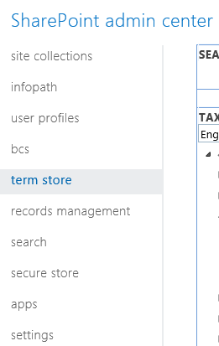

* Expand the Taxonomy node, look for MatterCenterTerms node and expand it
* Right-click on the “Clients” term set and select “Create Term” as shown below:

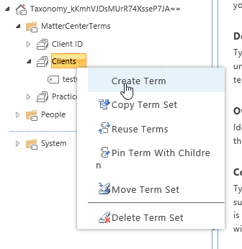

* Enter the name of the Site collection, the term should be created

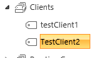

* Now, go to the Custom Properties tab and in the Shared Properties section, select Add
* Enter following values one after other:

|  |  |
| --- | --- |
| **Shared Property Name** | **Value** |
| ClientID | Some number (for e.g. 100002) |
| ClientURL | <Site collection URL> |

* After adding above values, click on save button.
* Right-click on the Client ID term set and then click on create term as shown below:

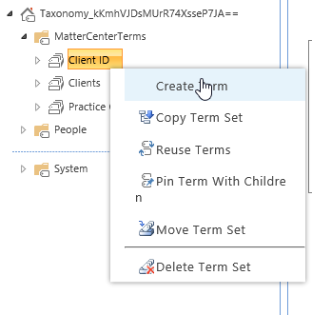

* Enter the number which we previously inserted in above mentioned table.
* The new term should be added as shown below:

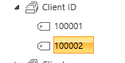

1. Activate Document ID feature on the Site collection:

* Navigate to site settings
* Click on Site collection features

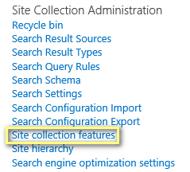

* Enable the Document ID settings feature



* Navigate to Document ID settings tab

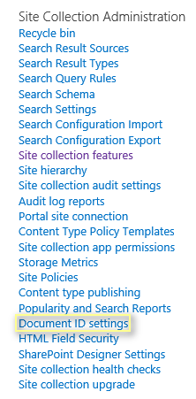

* Enter the details and click OK

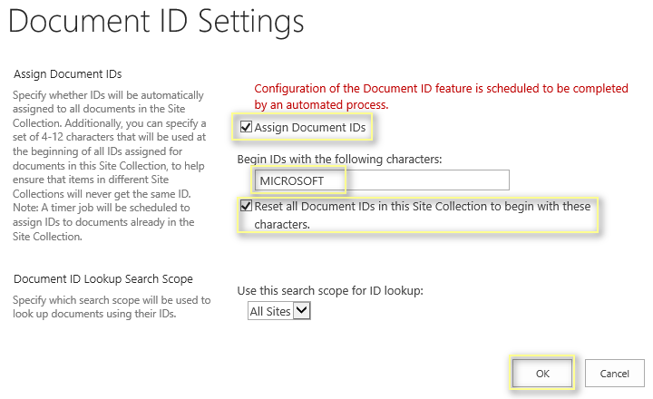

1. Provision Web dashboard page:

* To provision web dashboard at Tenant level
* Navigate to ‘Site contents’ of Tenant

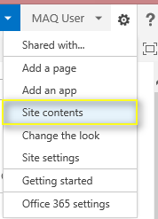

* Navigate to ‘Site Pages’

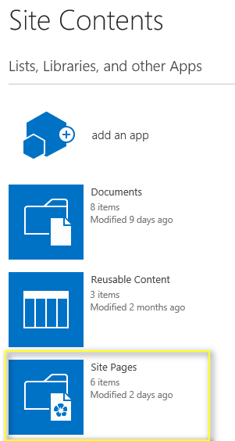

* Update web dashboard URL in ‘WebDashboardSPTemplate’ HTML.

Location for ‘WebDashboardSPTemplate’= “../mattercenter-master/tree/master/cloud/src/deployments/Static Content/HTML/ WebDashboardSPTemplate .html”

* URL should be Azure web dashboard as below:



* Update the catalog URL in script as below:



* Upload following HTML page under ‘Site Pages’
  1. WebDashboardSPTemplate.html
* Create a new page using Wiki template and name it as ‘MatterCenterHome’.

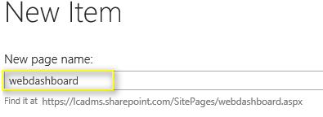

* To create new web part, we have to perform following steps
  1. Add “Content Editor” web part on the page

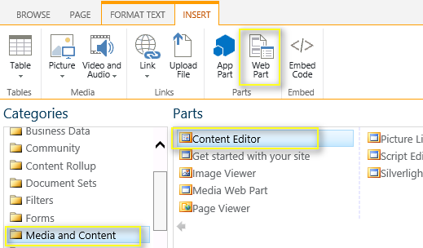

* Configure web part with following settings
  1. Provide URL of “WebDashboardSPTemplate.html” page which was uploaded in Site Pages
  2. Make chrome type as ‘None’

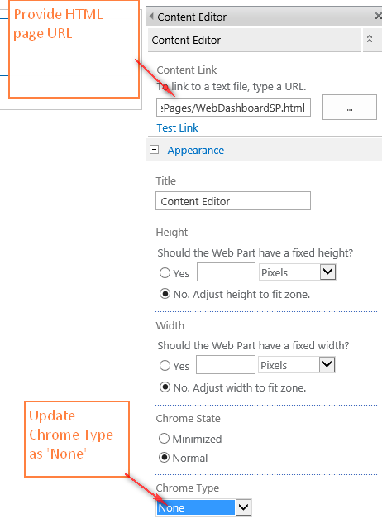

* Click on ‘Save’ button
* Verify that web dashboard is loading fine

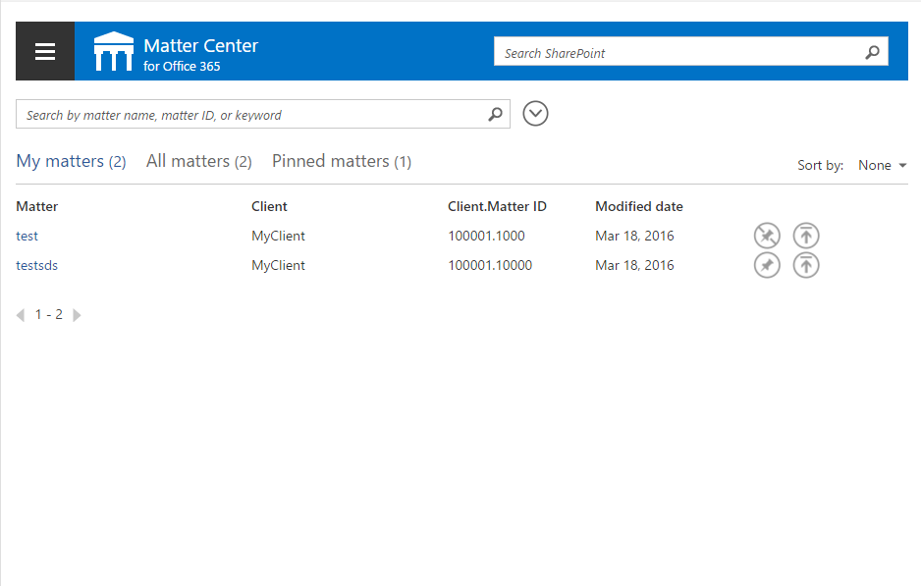

1. Steps for Provisioning settings page at Site collection level:

**Settings page configurations**

* Navigate to the Site collection that was just provisioned

1. Navigate to ‘Site contents’



1. Navigate to ‘Site Pages’



* Update settings page URL in ‘SettingsSP’ HTML.

Location for ‘SettingsSP’ = “../mattercenter-master/tree/master/cloud/src/deployments/Static Content/HTML/SettingsSP.html”

* URL should be Azure settings page as below:



* Update the catalog URL in Script as below:



1. Upload following HTML page under ‘Site Pages’

* SettingsSP.html
* Create a new page using Wiki template and name it as ’Settings’.

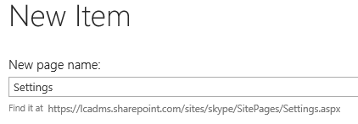

1. To add new web part, we have to perform following steps

* Add “Content Editor” web part on the page



1. Configure web part with following settings

* Provide URL of “SettingsSP.html” page which was uploaded in Site Pages
* Make chrome type as ‘None’

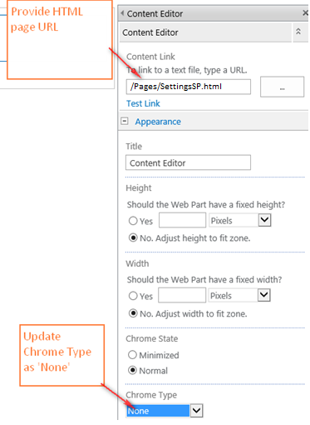

1. Click on ‘Save’ button
2. Select “Site Contents” and then select “Site Pages” as shown below:



1. Click on “…” icon on “Settings.aspx” row as shown below:

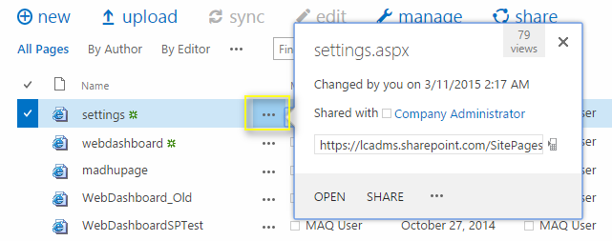

1. In the fly out that opens, click on “…” and then select “Shared With” as shown below:

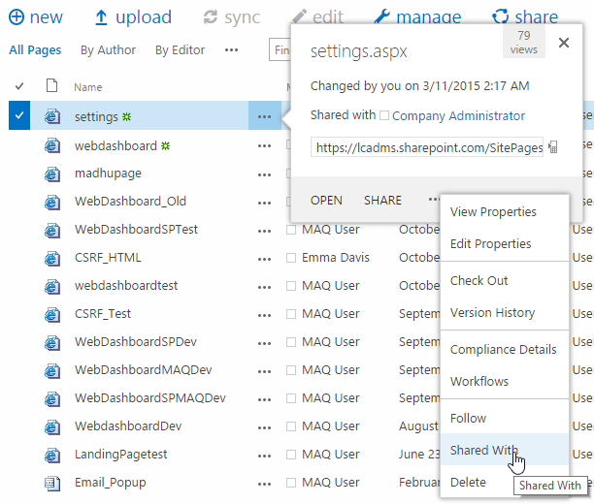

1. In the popup that opens up, select “Advanced” as shown below:

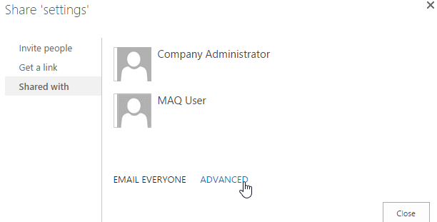

1. In the page that opens up, click on “Stop Inheriting Permissions”

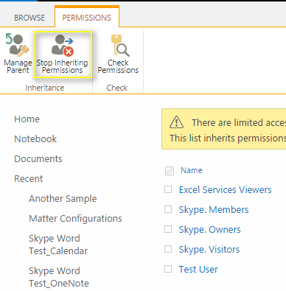

1. Remove the permissions of all the users/groups except for “Owners group” as shown below:

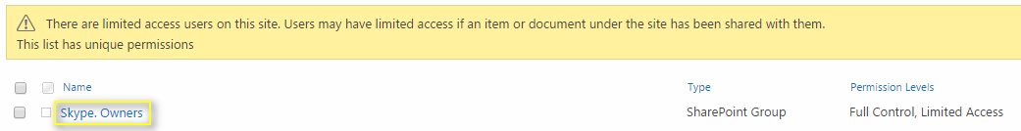

1. Steps for Provisioning Settings page at Tenant level:

For provisioning the Setting page at Tenant level, perform the step no. 4 similarly

**Settings list configurations**

1. Create configurations list by following below steps:

* Go to “Site Contents”:



* Click on “add an app, in the page that opens up Select “Custom list” as shown below:

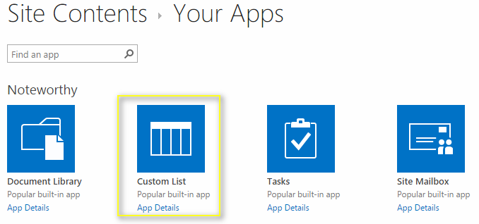

* Provide the name as “Matter Configurations” as shown below:

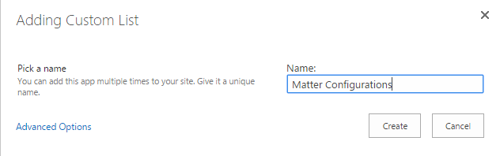

* In the page that opens up, click on “List” tab on the top and select “Create Column” as shown below:

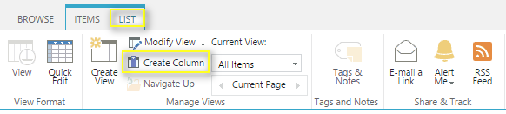

* In the popup that opens up, enter “ConfigurationValue” and Select “Multiple lines of text” and click on Ok button as shown below:

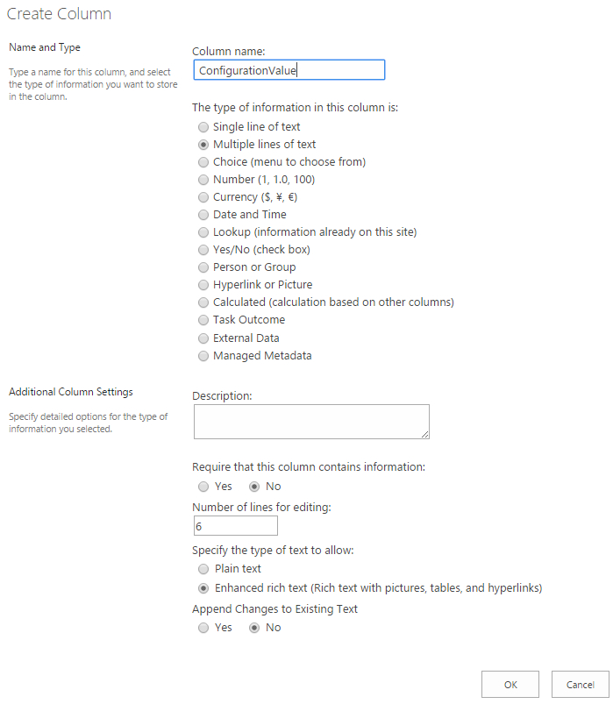

* Go to “List Settings” from the “List” tab and select “Permissions for this list” as shown below:

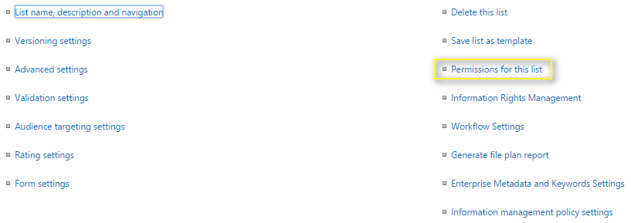

* In the page that opens up, click on “Stop Inheriting Permissions” and in the alert box click on “Ok” button as shown below:



* Change the permissions to “Read” of all the groups/users except for Owners group as shown below:

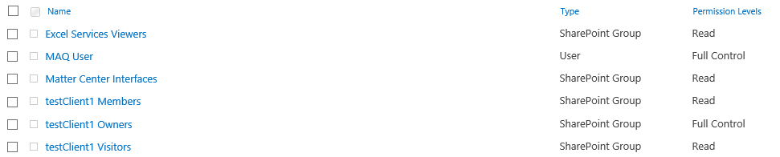

* Verify that settings page is loading fine

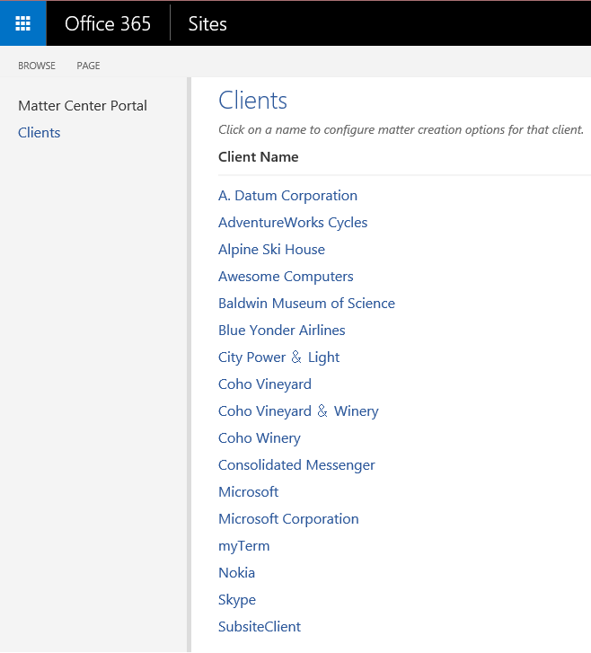

**Note**: We cannot hide a SharePoint list which is created using UI

# Appendix B

## Change app settings on Azure

1. Go to Azure Portal using the following URL: <https://manage.windowsazure.com>
2. Enter the credentials it asks for, then from the left navigation select “Web Apps” and then select the web app where you hosted “Matter Center Service” or “Matter Center Site”, as shown below:

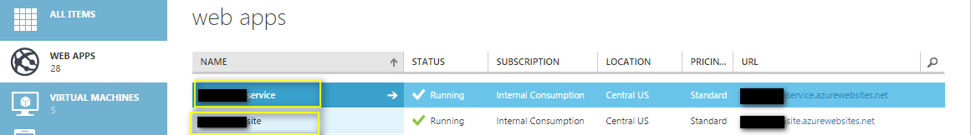

1. Now click on “Configure” tab and go to “app settings” section as shown below:

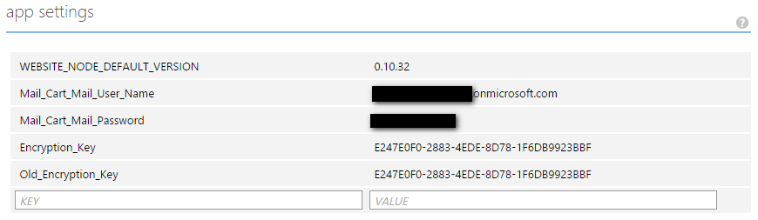

1. Update the field as per the requirement and then click on “Save” button as shown below:

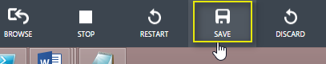

1. Success message should be displayed after clicking on “Save”.

# Appendix C

## Publish Content types from Content Type Hub

1. Go to Content type hub site collection, by using the following url: https://<tenant>/sites/contentTypeHub
2. For e.g. <https://myexampletenant.sharepoint.com/sites/contentTypeHub>
3. Go to Site Settings > Site Content types as shown below:

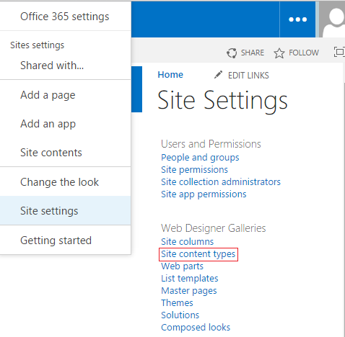

1. In the page that opens up, there will be a group called _MatterCenter as shown below:

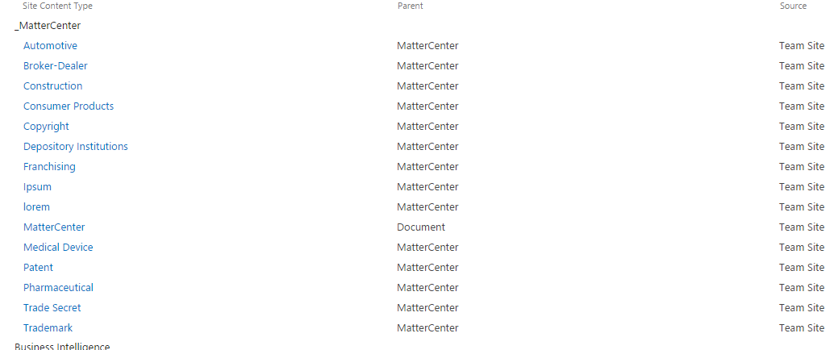

1. For each content type, click the link, choose the Manage publishing for this content type and select ok to publish the content type. Content types can take between 1-48 hours to publish to all the site collection. To verify the publishing is complete, go to the site collection you would like to create a matter on, click Settings > Site Content Types and verify that the _MatterCenter group and the content types are listed there.

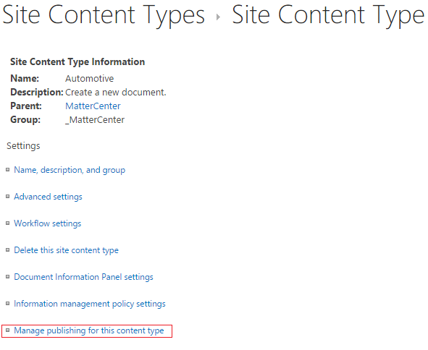

# Appendix D

## Add admin account to term store admin

1. Go to Admin center by typing the following URL in the browser: https://<tenant>-admin.sharepoint.com
2. For e.g. <https://mysharepointtenant-admin.sharepoint.com>
3. Select “term store” from the left navigation menu



1. Select “Taxonomy” node and in the Term Store Administrators, add the admin account as shown below:

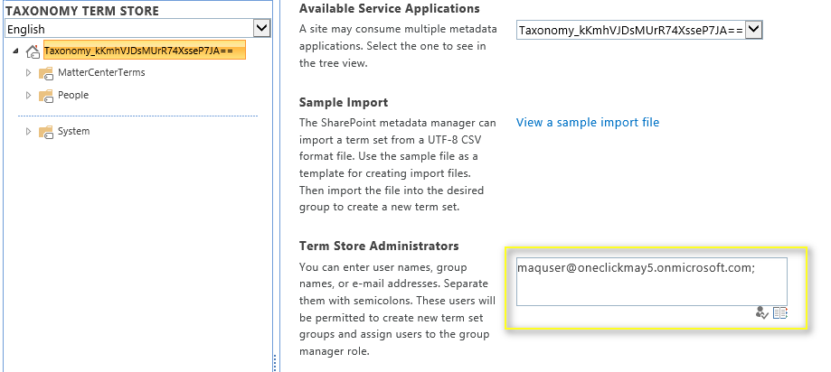

1. Click on Save button

# Appendix E

## Steps to create Azure redis cache

1. Login to new [Azure](https://portal.azure.com/) management portal
2. Click on New from the left panel

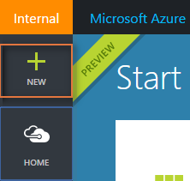

1. Click on Data + Storage > Redis Cache

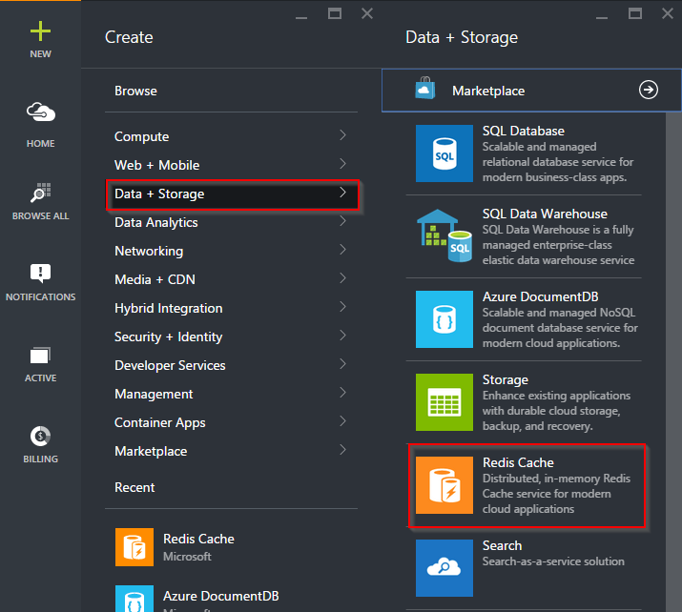

1. Enter required details and click on Create Button (fill in the fields shown below):

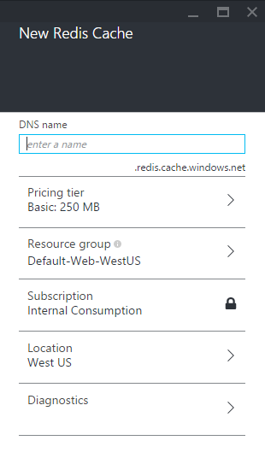

Recommendation:

* Select Pricing tier as per need. Recommendation is to use C0 Basic
* Select Redis Cache location same as of Azure Web Sites which are created for deploying Matter Center app

1. It will take around 20-30 minutes for Azure Redis cache to be completely ready, once ready open the Azure Redis cache
2. Click on the keys icon as shown below:

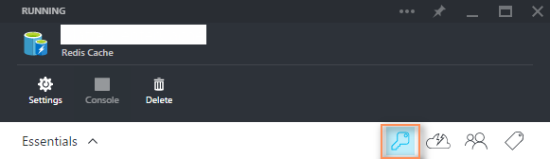

1. In the window that opens on the right side, copy the value of the primary key and add it in below table:

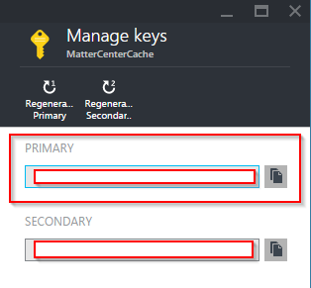

1. Also copy the host name of the cache and add it in below table:

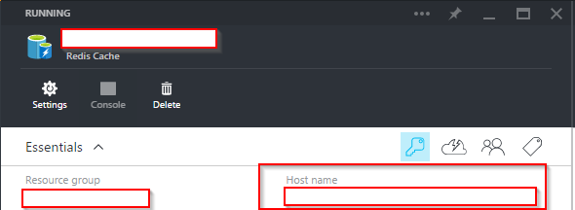

|  |  |
| --- | --- |
| **Name** | **Value** |
| Azure Redis Primary Key | <Value> |
| Azure Redis cache host name | <Value> |

## Update service’ appsettings

1. Login to new [Azure](https://portal.azure.com/) management portal
2. Click on Browse All > Web Apps

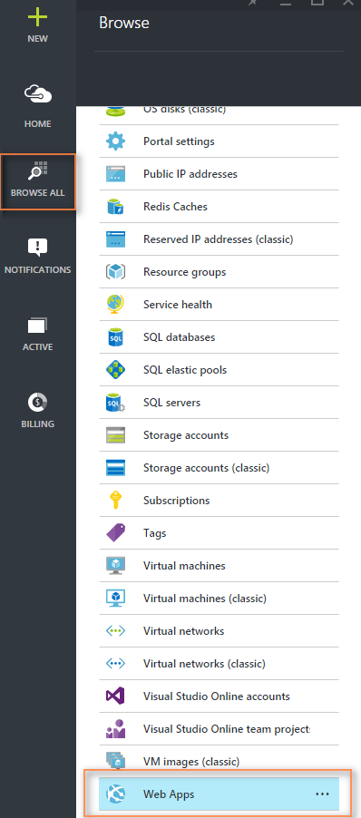

1. Select the service web app that you created in Create and configure websites step
2. In the window that opens up, select “All Settings”

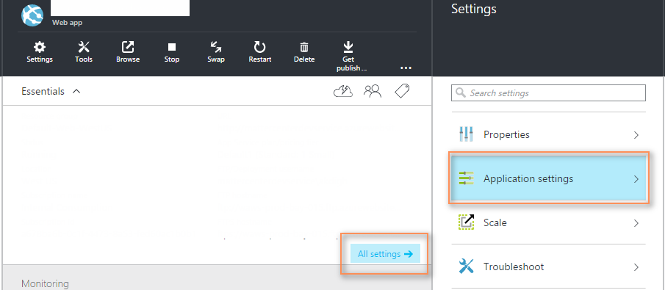

1. Enter following values in the app settings section:

|  |  |
| --- | --- |
| **Key** | **Value** |
| Cache_Host_Name | Value added in previous table for host name |
| Cache_Primary_Key | Value added in previous table for Cache primary key |

1. After the changes are done, click on “Save button”

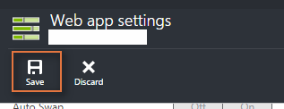

# Appendix F

## List of resource files to update in the solution

* Microsoft.Legal.MatterCenter
  + Break URL (Elements.xml)
    - UrlAction
  + Send to OneDrive (Elements.xml)
    - UrlAction
  + Sync (Elements.xml)
    - UrlAction
  + UpdateAndCheckIn (Elements.xml)
    - UrlAction
  + UpdateAndCheckOut (Elements.xml)
    - UrlAction
  + AppManifest (Right click view code)
    - Product ID (Generate GUID with Visual Studio tool)
    - Start page
    - ClientId
* Microsoft.Legal.MatterCenter.OneDriveRibbon
  + RibbonCustomAction (Elements.xml)
    - CommandActions
  + AppManifest (Right click view code)
    - ProductID
    - StartPage
    - ClientId
* Microsoft.Legal.MatterCenter.ProviderService
  + App_GlobalResource\Constants.resx
    - Central_Repository_URL (app catalog url)
    - Common_CSS_File_Location
    - Common_JS_File_Location
    - LogTableName
    - Matter_Landing_Page_CSS_File_Name (If your app catalog is not at /sites/catalog)
    - Matter_Landing_Page_jQuery_File_Name (If your app catalog is not at /sites/catalog)
    - Matter_Landing_Page_Script_File_Name (If your app catalog is not at /sites/catalog)
    - Search_Result_Source_ID (Only if doing manual deployment, otherwise scripts will handle)
    - Site_Url
    - Tenant_WebDashboard_Link – Update for Localized installs
    - Template_Document_Library_Link – Update for Localized installs
  + Web.config
    - ClientId
    - ClientSecret
    - HostedAppHostNameOverride
    - Access-Control-Allow-Origin
* Microsoft.Legal.MatterCenter.SharePointAppWeb
  + App_GlobalResources\Constants.resx
    - App_Redirect_URL
    - Application_Insight_App_Id
    - Central_Repository_Url
    - ClientId
    - Delve_Link
    - Image_Document_Icon (needs to be updated for manual deployments)
    - Image_General_Document (needs to be updated for manual deployments)
    - Learn_More_Link
    - Legal_Briefcase_Service_Url
    - Matter_Provision_Service_Url
    - Office_JS_URL
    - Search_Service_Url
    - Site_Url
    - Tenant_Url
    - UILogTableName
  + ApplicationInsights.config
    - InstrumentationKey (Fill in as NA if not using Application Insights)
  + App_LocalResources\Webdashboard.resx
    - Feedback_and_Support
  + MasterPage
    - MatterCenterMaster.Master
      * ContextualHelpSupport
      * FeedbackAndSupport
      * PrivacyAndCookies
      * TermsofUse
  + Pages
    - Footer.html
      * Feedbackandsupport
      * Also update remaining 2 placeholders with respective hyperlinks.
  + Web.config
    - ClientId
    - ClientSecret
    - HostedAppHostNameOverride
* Microsoft.Legal.MatterCenter.Utility
  + Contsants.resx
    - Provision_Matter_App_URL
  + Log.resx
    - CloudStorageConnectionString
    - UtilityLogTableName
* Microsoft.Legal.MatterCenter_Office
  + Microsoft.Legal.MatterCenter_OfficeManifest
    - Id (Generate GUID with Visual Studio tool)
    - IconURL
    - AppDomains (UI, Service, SharePoint)
    - SourceLocation
* Microsoft.Legal.MatterCenter_Outlook
  + Microsoft.Legal.MatterCenter_OutlookManifest
    - Id (Generate GUID with Visual Studio tool)
    - IconUrl
    - AppDomains (UI, Service, SharePoint)
    - SourceLocation x 4

## List of Configuration files to update in the Helper Utilities solution

* Microsoft.Legal.MatterCenter.UploadFile
  + App.config
    - FeedbackLink
    - TermsOfUseLink
    - PrivacyLink
    - LogoLink

# Appendix G

## Create Application Insights

1. Login to new [Azure](https://portal.azure.com/) management portal

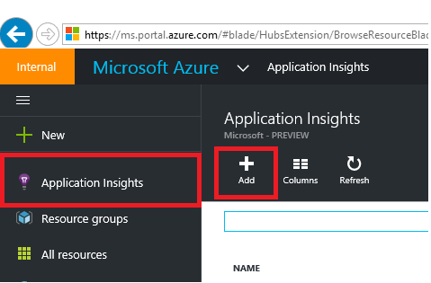

1. Click on Application Insights > Add

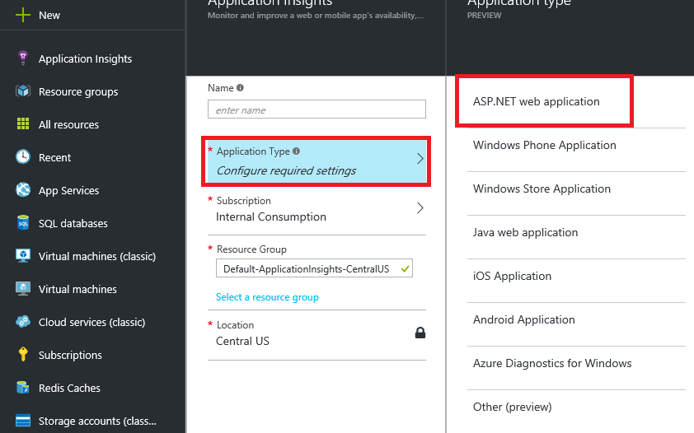

1. Select Application Type as ASP.NET web application and fill required details
2. Click on create button
3. Please Note, you should select the Region closest to your websites created in above step
4. Navigate to newly created Application Insights account and make note of Instrumentation Key

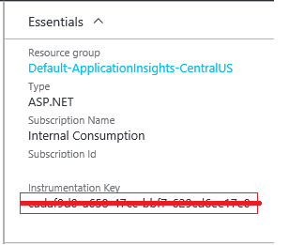

1. This Instrumentation Key will be required in Matter Center Excel config file

# Troubleshooting Deployment Issues

* 1. Failed to install Exchange app

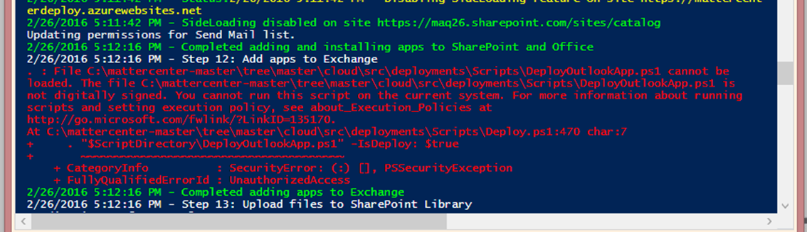

Resolution: Setup Outlook account of the user of which exchange credentials are used during deployment.